Kubernetes Deployment Management
Writing deployment.yaml in the editor
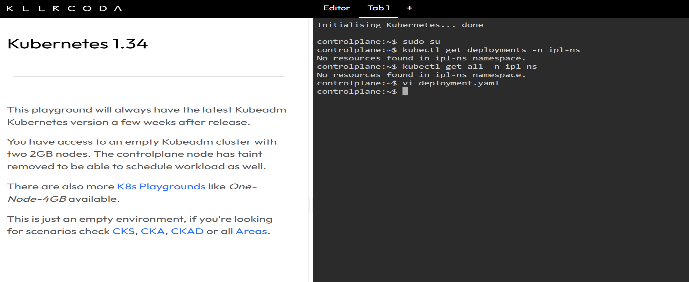
- You are defining a Deployment named ipl-deployment
- It will run in namespace ipl-ns
- It will create 3 replicas (pods)
- Each pod runs nginx:latest on port 80
- The label app: ipl is used to connect Deployment → ReplicaSet → Pods

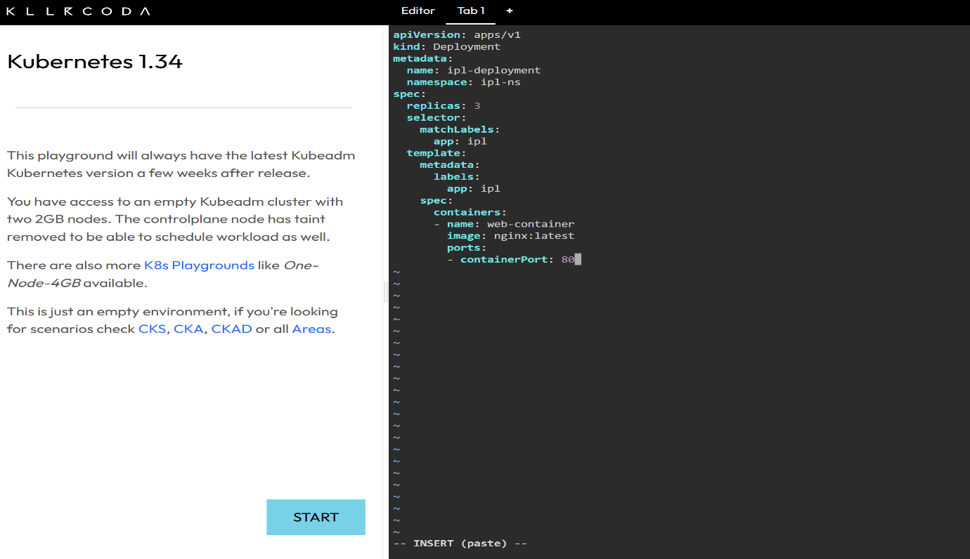

Creating the namespace and deployment
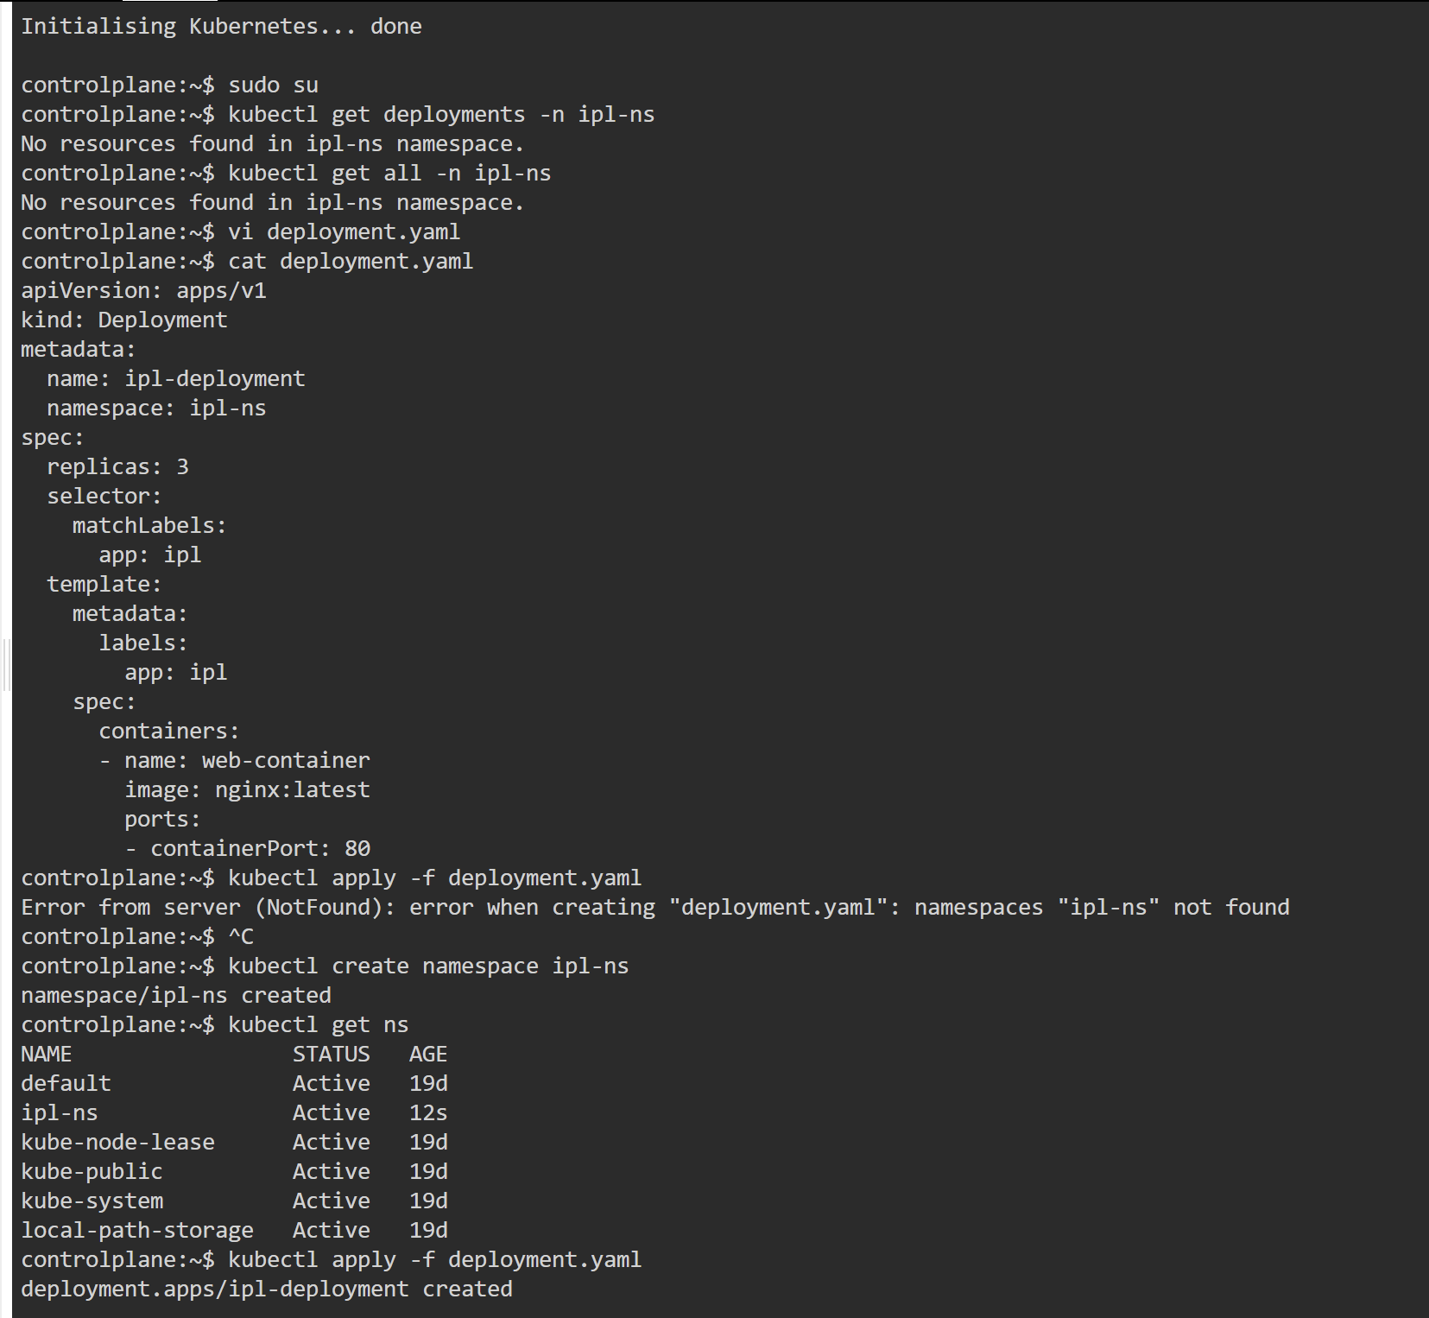
- Kubernetes does not auto-create namespaces
- Your YAML says namespace: ipl-ns
- But that namespace did not exist yet
- So Kubernetes refused to create the Deployment
- You created the namespace ipl-ns
- Now Kubernetes successfully created the Deployment
Checking cluster before creating deployment
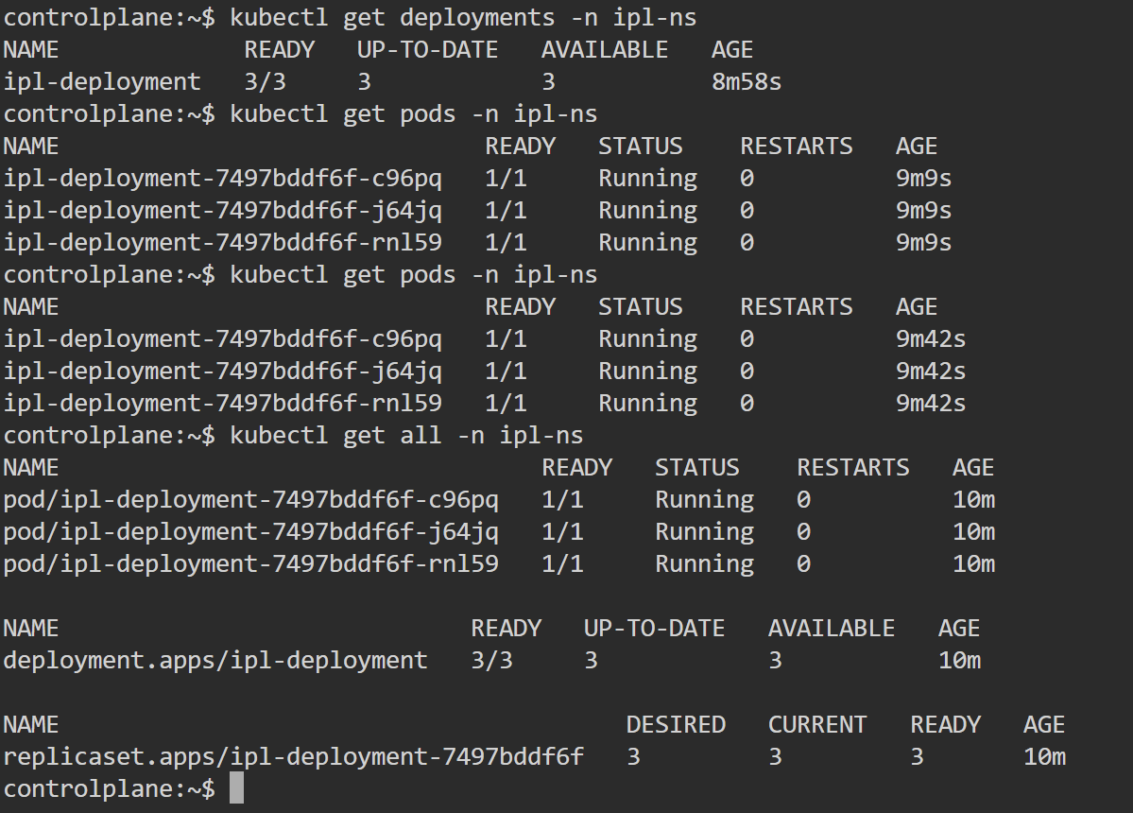
- Deployment is working correctly
- It created a ReplicaSet
- ReplicaSet created 3 Pods
- All pods are healthy

- 3 Pods (Running)
- 1 Deployment (ipl-deployment)
- 1 ReplicaSet
- So Kubernetes is managing everything properly.
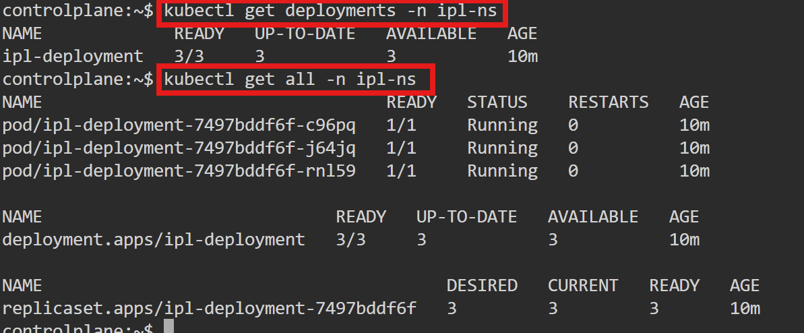

- Replicas: 3 desired | 3 updated | 3 available
- Strategy: RollingUpdate
- Image: nginx:latest
- NewReplicaSet: ipl-deployment-7497bddf6f
- Events: shows scaling from 0 → 3
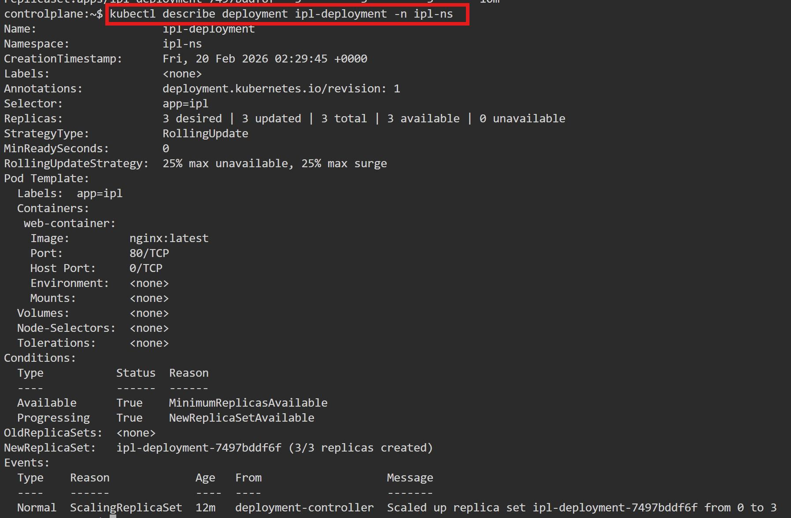
Describing one Pod
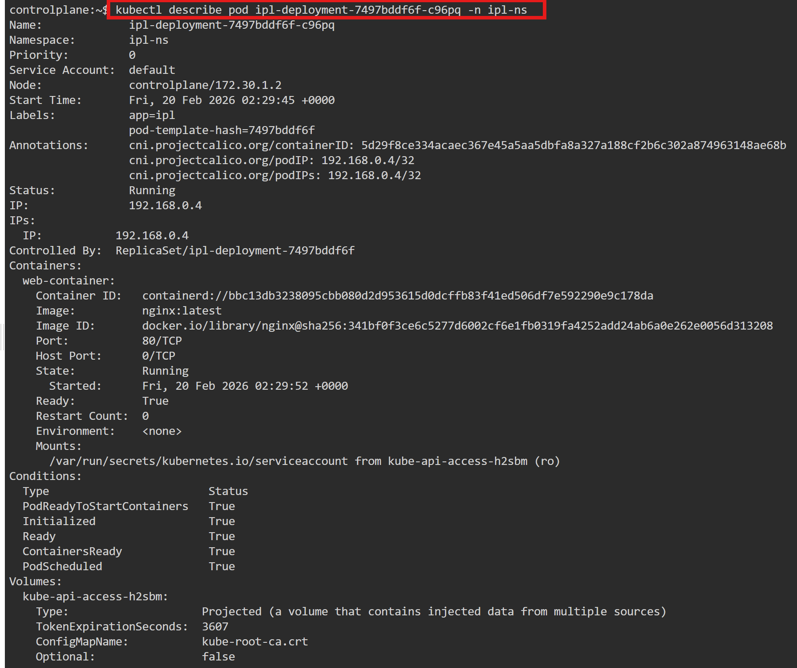
- It is controlled by a ReplicaSet
- Which is controlled by the Deployment
- Confirms the exact image running inside the pod
Rollout History
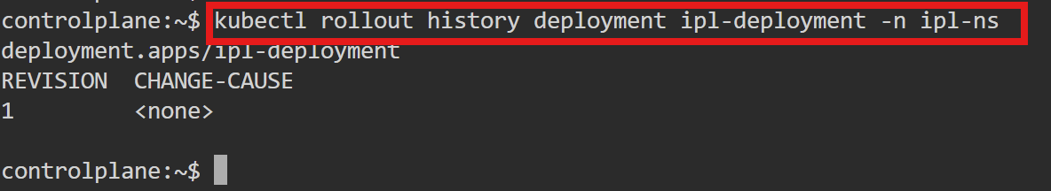
- You currently have only one version of the Deployment
- No update has been done yet
- After you change the image and apply again, you’ll see Revision 2, 3
Rollout Status
- Deployment is stable
- All replicas are updated and available
- No update is in progress
- Cluster is in healthy state

Describing Deployment
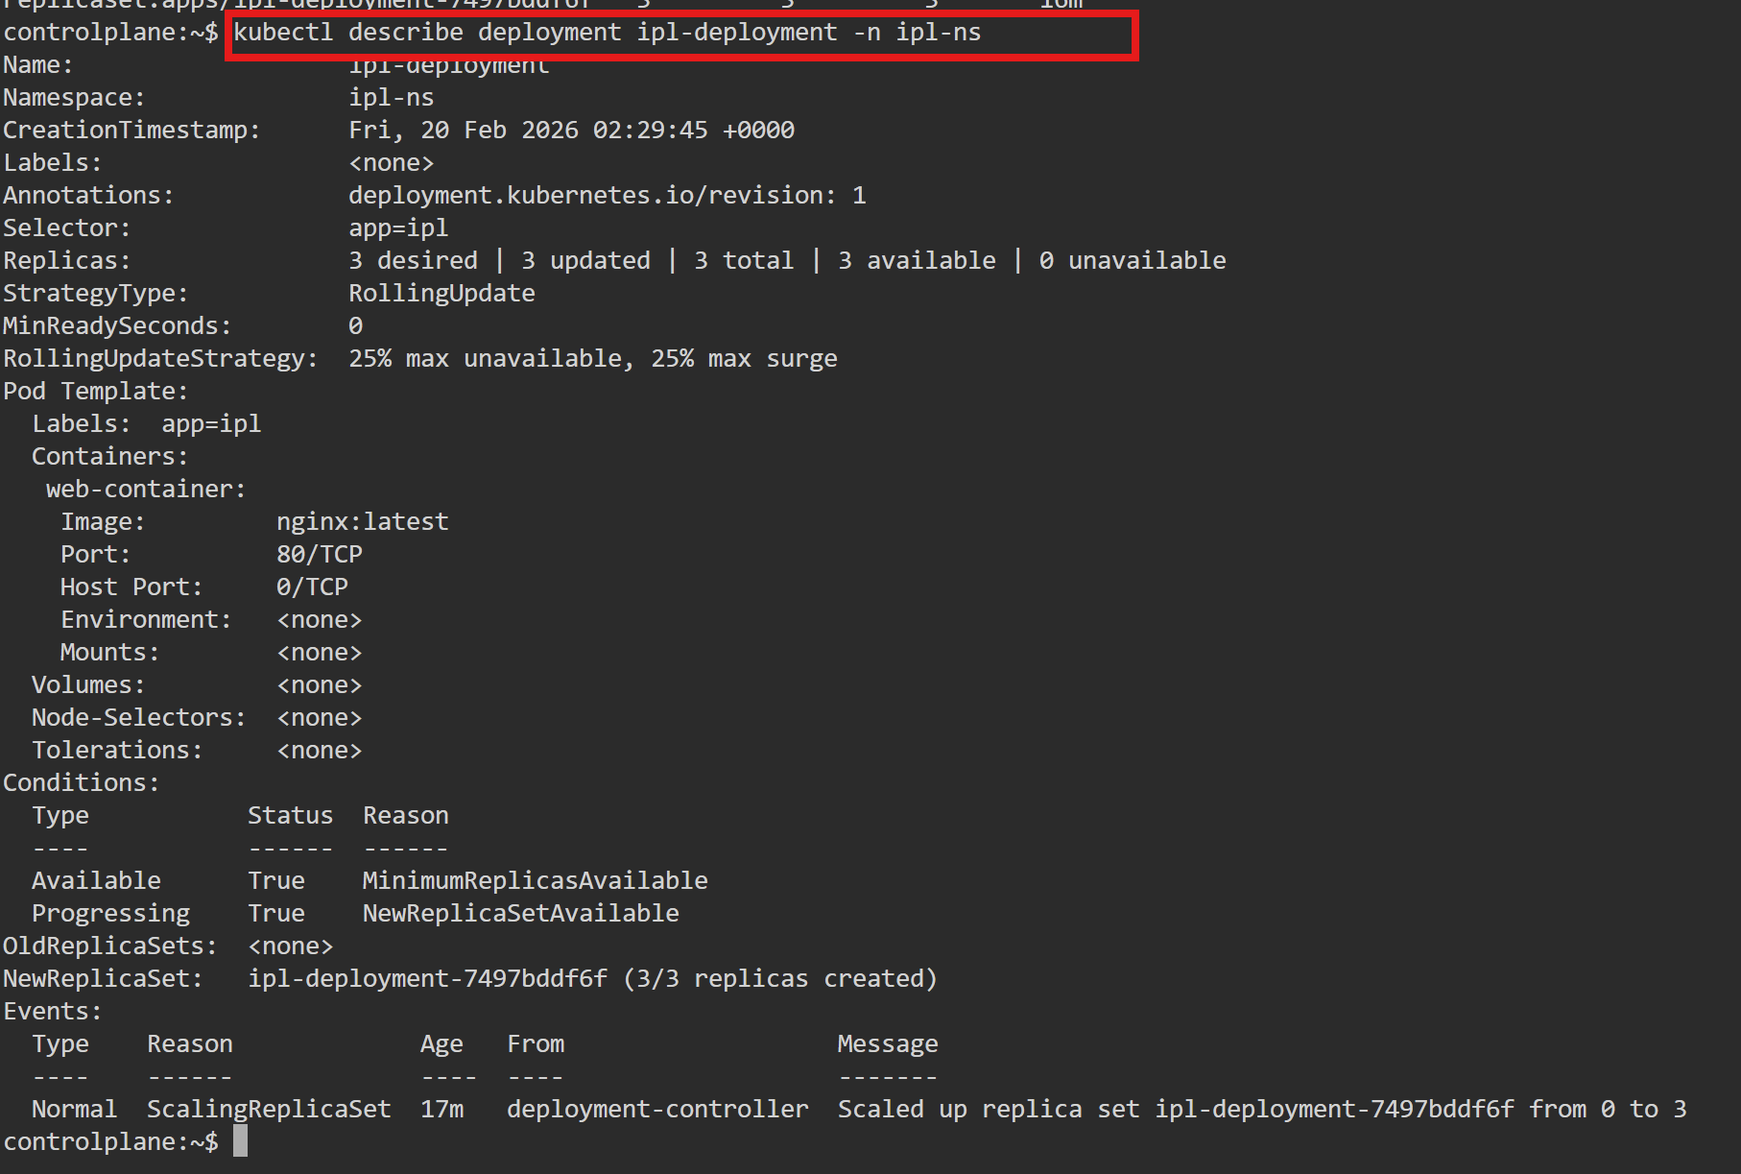
- Confirms current state of deployment
- Confirms no old ReplicaSets yet (because no update done)
- Confirms everything is stable and running

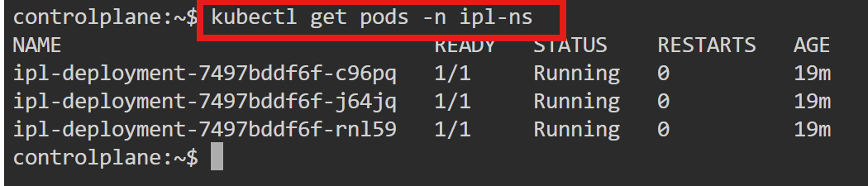
- You have 3 pods running in namespace ipl-ns
- All are created by your Deployment ipl-deployment
- 1/1 → Each pod has 1 container, and it is ready
- Running → Pods are healthy and working
- RESTARTS 0 → No crashes so far
- AGE 19m → Pods were created ~19 minutes ago

full details of one pod
